A Brief Study of
Market dynamics of key GSM products of Reliance communications ltd. Vis-à-vis competition

Submitted in Partial Fulfillment of the Requirement for the Award of the Degree of

MASTER OF BUSINESS ADMINISTRATION
at
Indian Institute of Technology, Kanpur

Submitted by :Rao Randhir Singh Roll.No.- 13125042
Session : 2013-2015

DECLARATION

It is declared that the summer Training Project Report Entitled " Market dynamics of key GSM products of Reliance communications ltd. Vis-à-vis competition” has been prepared as the part for the completion of the degree of Master of Business Administration from the Indian Institute of Technology, Kanpur and it is based on my original work and will be used only for my academic purpose. It will not be produced in any condition as a source of information to an industry.

Date :- Rao Randhir Singh
Patna Roll.No.-13125042
Session : 2013-15

PREFACE

The summer training provides a student with an opportunity to understand in full the real life -working environment, which is a bit different from normal theory classes. Our class knowledge attains maturity and perfection through application in the practical field application of management principle in all branches whether personnel, finance, information technology etc results in more sufficient and effective utilization of available resources .Especially marketing being a dynamic in management curriculum is to bridge to gap between theory and application.

The summer training placement program is an integral part of MBA course in Indian Institute of Technology, Kanpur.

I have done my summer training for Reliance Communications Ltd, Patna. My topic of study was “Market dynamics of key GSM products of Reliance communications ltd. Vis-à-vis competition”.

I have no hesitation in saying that this study has given me the confidence to face the real market world.

I have tried my best to do honesty and justice to the topic and any weakness and shortcoming is unintentional and is regretted.

ACKNOWLEDGEMENT

Many factors contribute for the completion of a project work directly or indirectly. But I would like to express my deep sense o gratitude to few for their valuable contributions.

Firstly I recognize very clearly that the great debt I owe both to the almighty God my parents and it is grace that I am stand where I am stand where I am today.

I would like to express my sincere reverence to all faculty members at IITK for giving insight of the concept, which is prefect blend of theoretical understanding and practical aspects at regular interval.

I am extremely grateful to Mr Sandipan Bhattacharjee of Reliance Communication Ltd, Patna, whose guidance has made this study possible, his knowledge, experience, disciplined approach, constructive criticism and valuable suggestions have been a source of inspiration to me.

CONTENTS

Chapter - 1

Introduction to the study

Objective of the study

Scope of the Study

Chapter - 2

Company Profile

Chapter - 3
- Research and Data collection methodology

Chapter - 4
- Data Analysis and Interpretation
- SWOT Analysis

Chapter - 5
- Findings
- Recommendations

Chapter - 6
- Conclusion
- Limitations
- Bibliography

Chapter - 1

Introduction to the study

Objective of the study

Scope of the Study

Introduction to the study

As a part of academic curriculums in partial fulfillment of "Master of Business Administration" the trainee has done this summer project at Reliance Communications Ltd, Patna. The introduction as well as completion of the study is at Reliance, Patna and other areas of Bihar and Jharkhand.

The study centered to take strategic decisions in support of Reliance Communications Ltd in the field of marketing. The main scope of this study is to ascertain various methods to increase the sales volume of the concern through increasing the number of recharges per day for the offered products in study. The method includes regular product information to the buyers, creating a brand position in the market and taking measures to make the brand remain in its position and expand. One of the important aspects of this study is also to increase the market segment for the products.

Objective of the study

This study has its own purposes for the student & organisation. This is a survey work for any of the problem existing in the organisation. The major purpose of this study is to expose, express & analyse the situation existing in the organisation by using well crafted skill, stamina, analytical power line towards the problem solution.
These can be outlined as :-
(1) To create awareness among customers and retailers of Bihar and Jharkhand about the new GSM plans for local, roaming and internet products of Reliance.
(2) To assess the competitive strength of the product and consequences of plans.
(3) To define the potential market for Reliance product and to determine general marketing conditions and product distribution techniques.
(4) To conduct demographic and product image research in terms of product quality, pricing, services and plans offered by questioning customers, retailers and distributors.
(5) To study how the customer choose their respective telecom service.
(6) To find out ways to increase sales through effective modes of promotion and advertisement
(7) To find out the strength and weakness of Reliance and its competitors.
(8) To know the perception of customers, distributors and retailers about Reliance in terms of Price and quality of its products and the quality of service that it offers to its retailers and customers

Scope of the Study

First of all, I analysed the market as to by which factors sales of the product under study can be increased. So, under supervision of different function of Management i.e. Planning, organising, staffing, directing, controlling. For efficient implementation of these function various skills with a person is required by the help of actual development comes through practical study for management education.

The scope of this study to know different factor and to develop the ability of decision-making & decision always be taken at right time. So, as I have to study the increase of Sales for the new launches in Bihar and Jharkhand market for Reliance Communications.

I have to find out it is viable or more viable & why?

The scope of study is important for research of particular products of Reliance Communication.

Chapter - 2

Company Profile

Company Profile

Introduction to the Organization
Few men in history have made as dramatic a contribution to their country’s economic fortunes as did the founder of Reliance, Sh. Dhirubhai H Ambani. Fewer still have left behind a legacy that is more enduring and timeless.
As with all great pioneers, there is more than one unique way of describing the true genius of Dhirubhai: the corporate visionary, the unmatched strategist, the proud patriot, the leader of men, the architect of India’s capital markets, the champion of shareholder interest.
But the role Dhirubhai cherished most was perhaps that of India’s greatest wealth creator. In one lifetime, he built, starting from the proverbial scratch, India’s largest private sector enterprise.
When Dhirubhai embarked on his first business venture, he had a seed capital of barely US$ 300 (around Rs 14,000). Over the next three and a half decades, he converted this fledgling enterprise into a Rs 60,000 crore colossus—an achievement which earned Reliance a place on the global Fortune 500 list, the first ever Indian private company to do so.
Dhirubhai is widely regarded as the father of India’s capital markets. In 1977, when Reliance Textile Industries Limited first went public, the Indian stock market was a place patronised by a small club of elite investors which dabbled in a handful of stocks.
Undaunted, Dhirubhai managed to convince a large number of first-time retail investors to participate in the unfolding Reliance story and put their hard-earned money in the Reliance Textile IPO, promising them, in exchange for their trust, substantial return on their investments. It was to be the start of one of great stories of mutual respect and reciprocal gain in the Indian markets.
Under Dhirubhai’s extraordinary vision and leadership, Reliance scripted one of the greatest growth stories in corporate history anywhere in the world, and went on to become India’s largest private sector enterprise.
Through out this amazing journey, Dhirubhai always kept the interests of the ordinary shareholder uppermost in mind, in the process making millionaires out of many of the initial investors in the Reliance stock, and creating one of the world’s largest shareholder families.
A dream come true



The late Dhirubhai Ambani dreamt of a digital India — an India where the common man would have access to affordable means of information and communication. Dhirubhai, who single-handedly built India’s largest private sector company virtually from scratch, had stated as early as 1999: “Make the tools of information and communication available to people at an affordable cost. They will overcome the handicaps of illiteracy and lack of mobility.”
It was with this belief in mind that Reliance Communications (formerly Reliance Infocomm) started laying 60,000 route kilometres of a pan-India fibre optic backbone. This backbone was commissioned on 28 December 2002, the auspicious occasion of Dhirubhai’s 70th birthday, though sadly after his unexpected demise on 6 July 2002.
Reliance Communications has a reliable, high-capacity, integrated (both wireless and wireline) and convergent (voice, data and video) digital network. It is capable of delivering a range of services spanning the entire infocomm (information and communication) value chain, including infrastructure and services — for enterprises as well as individuals, applications, and consulting.
Today, Reliance Communications is revolutionising the way India communicates and networks, truly bringing about a new way of life.

Think big. Think different. Think ahead.

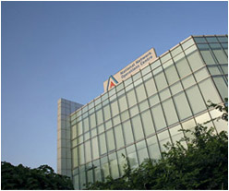
Dhirubhai preached — and personally practised — one mantra throughout his life: Dream with conviction.
He built the Reliance empire from scratch and, in a short span of 25 years, it catapulted to become one of the top Fortune 500 corporations of the world — an achievement unparalleled in history.
He was deeply rooted in traditional Indian values, and at the same time, Dhirubhai possessed a very modern outlook - truly that of a 21st century person. His corporate philosophy was short, simple and incredibly effective: “Think big. Think different. Think fast. Think ahead. Aim for the best.” This was clearly reflected in his passion for mega-sized projects, as well as his fascination for cutting-edge technology and desire to always achieve the highest possible productivity. At Reliance, Dhirubhai was a pillar of inspiration for one and all. By practicing what he preached, he inspired and encouraged everyone to surpass the best in the world.
Dhirubhai fully realised that true empowerment of the people is possible only through education. Being an effective communicator, he continued to inspire, guide, educate and motivate everyone through his communications. He was a firm believer in the power of information and communication, and how it can be utilised and turned to the advantage of one and all, by making time and distance irrelevant.
He would always say that if a telephone call could be made cheaper than a postcard, it would transform every home, empower every Indian, remove every obstacle to opportunity and growth, and tear apart every barrier that divides Indian society. He was convinced that infocom could energise enterprises, drive governance, and render learning an interesting experience, apart from making life exciting.
Keeping his conviction as our credo, Reliance Communications is committed to transform Dhirubhai’s dream into a reality.

Business
India’s leading integrated telecom company Reliance Communications is the flagship company of the Anil Dhirubhai Ambani Group (ADAG) of companies. Listed on the National Stock Exchange and the Bombay Stock Exchange, it is India’s leading integrated telecommunication company with over 100 million customers.
Our business encompasses a complete range of telecom services covering mobile and fixed line telephony. It includes broadband, national and international long distance services and data services along with an exhaustive range of value-added services and applications. Our constant endeavour is to provide an enhanced customer experience and achieve customer satisfaction by upscaling the productivity of the enterprises and individuals we serve.
Reliance Mobile (formerly Reliance India Mobile), launched on 28 December 2002, coinciding with the joyous occasion of the late Dhirubhai Ambani’s 70th birthday, was among the initial initiatives of Reliance Communications. It marked the auspicious beginning of Dhirubhai’s dream of ushering in a digital revolution in India. Today, we can proudly claim that we were instrumental in harnessing the true power of information and communication, by bestowing it in the hands of the common man at affordable rates.

We endeavour to further extend our efforts beyond the traditional value chain by developing and deploying complete telecom solutions for the entire spectrum of society.
Wireless
Reliance Mobile

With over 100 million subscribers across India, Reliance Mobile is India’s largest mobile service brand. Reliance Mobile services now cover over 24,000 towns, 6 lakh villages, and still counting.

We have achieved many milestones in this short journey. In 2003, AC Nielsen voted Reliance Mobile (formerly Reliance India Mobile) as India’s Most Trusted Telecom Brand. In July 2003, it created a world record by adding one million subscribers in a matter of just 10 days through its ‘Monsoon Hungama’ offer.
What sets Reliance Mobile apart is the fact that nearly 90 per cent of our handsets are data-enabled, and can access hundreds of Java applications on Reliance Mobile World.
Reliance Mobile has ushered in a mobile revolution by offering advanced multimedia handsets to the common man at very affordable rates. This innovative low pricing has increased the number of mobile phone users and its result is clearly reflected in the meteoric rise in India’s tele-density over the past four years.
Our pan-India wireless network runs on CDMA2000 1x technology, which has superior voice and data capabilities compared to other cellular mobile technologies. CDMA2000 1x is more cost-effective as it utilises the scarce radio spectrum more efficiently than other technologies do. Enhanced voice clarity, superior data speed of up to 144 kbps and seamless migration to newer generations of mobile technologies are some of its key differentiators.

PRODUCTS’ (under study) PROFILES
- Local Data pack (Only for GSM mobiles) :
All local calls at 25p/minute with a validity of 30 days
- Roaming pack (Only for GSM mobiles) :
Rs 46 plan : Talktime = 0 ; All outgoing calls at 40p/min; All incoming calls free; Valid for 30 days
Rs 115 plan : Talktime = 120 (in the main balance); All outgoing calls at 1p/second; All incoming calls free; Valid for 30 days
- Mobile internet data plan (Only for GSM mobiles) :
3G plan : 1GB data (unlimited whatsapp, facebook and twitter) ; Recharge of Rs 177; Valid for 30 days
2G plan : 1GB data (unlimited whatsapp, facebook and twitter); Recharge of Rs 125; Valid for 21 days

Competitors of the Organization

In Bihar Reliance faces competition from Airtel, BSNL, Idea, Tata Tele Services, Vodafone, Aircel and Uninor .
Airtel
The businesses at Bharti Airtel have been structured into three individual strategic business units (SBU’s) - Mobile Services, Airtel Telemedia Services & Enterprise Services. The mobile business provides mobile & fixed wireless services using GSM technology across 23 telecom circles while the Airtel Telemedia Services business offers broadband & telephone services in 95 cities and has recently launched a Direct-to-Home (DTH) service, Airtel digital TV. The company provides end-to-end data and enterprise services to the corporate customers through its nationwide fiber optic backbone, last mile connectivity in fixed-line and mobile circles, VSATs, ISP and international bandwidth access through the gateways and landing station.
Plans similar to Reliance’s products under study here : 1) All local calls at 40p/minute on a recharge of Rs 49, valid for 28 days and provides a talk time of Rs 9.
2) All local calls at 35p/minute for a Rs 68 recharge with a Rs 10 talk time and validity of 28 days
3) All local calls at 30p/minute on a Rs 70 recharge and with a validity of 28 days
4)1GB 3G at Rs 251 with a validity of 30 days and 1GB 2G data at Rs 155 and with validity of 28 days
5) All outgoing calls at 1.5p/second with incoming free for a recharge of Rs 73 and with a validity of 30 days
Vodafone
Vodafone Essar, formerly known as Hutchison Essar, is a cellular operator in India that covers 23 telecom circles in India. It is based in Mumbai. Vodafone Essar is the Indian subsidiary of Vodafone Group. Formerly, 33% share in the firm was owned by Essar Group. Vodafone Group bought out the 33% stake of Essar Group for $5 billion to became the sole owner of the firm. It is the second largest mobile phone operator in terms of revenue behind Bharti Airtel, and third largest in terms of customers. Vodafone had about 134.5 million customers as of February 2011.
Plans similar to Reliance’s products under study here :
- 1GB 2G at Rs 155 with a validity of 30 days and 1GB unlimited 2G at Rs 199 for 30 days
- 1GB 3G at Rs 251 for 30days
^{BSNL}
BSNL is India's oldest and largest Communication Service Provider (CSP). Currently has a customer base of 90 million as of June 2008. It has footprints throughout India except for the metropolitan cities of Mumbai and New Delhi which are managed by MTNL. As on March 31, 2008 BSNL commanded a customer base of 31.55 million Wireline, 4.58 million CDMA-WLL and 54.21 million GSM Mobile subscribers..
IDEA
Idea Cellular is a wireless telephony company operating in various states in India. It initially started in 1995 as a joint venture among the Tatas, Aditya Birla Group and AT&T by merging "'Wings Cellular'" operating in Madhya Pradesh, Uttar Pradesh (UP) West, Rajasthan and Tata Cellular as well as Birla AT&T Communications.
Initially having a very limited footprint in the GSM arena, the acquisition of Escotel in 2004 gave Idea a truly pan-India presence covering Maharashtra, Goa, Gujarat, Andhra Pradesh, Madhya Pradesh, Chattisgarh, Uttar Pradesh (East and West), Haryana, Kerala, Rajasthan and Delhi (inclusive of NCR).
The company has its retail outlets under the "Idea n' U" banner. The company has also been the first to offer flexible tariff plans for prepaid customers. It also offers GPRS services in urban areas.
Idea Cellular won the GSM Association Award for "Best Billing and Customer Care Solution" for 2 consecutive years.
AIRCEL
Aircel is a mobile phone service provider in India. It offers both prepaid and postpaid GSM cellular phone coverage throughout Tamil Nadu (including Chennai), Andhra Pradesh, Assam, North East India, Orissa, West Bengal (including Kolkata), Jammu and Kashmir, Bihar, Kerala, Himachal Pradesh & Mumbai. Aircel was founded by NRI businessman C Sivasankaran. Aircel is a joint venture between Maxis Communications Berhad of Malaysia and Apollo Hospital Enterprise Ltd of India. It is India’s seventh largest GSM mobile service provider with a subscriber base of over 18 million. It has a market share of 6.3% among the GSM operators in the country. As on date, Aircel is present in 17 telecom circles (including Assam, Bihar, Himachal Pradesh, Jammu & Kashmir, Kerala, North East, Orissa, Tamil Nadu, Karnataka, West Bengal, Delhi) and with licences secured for the remaining 10 of the 23 telecom circles, the company plans to become a pan-India operator by 2009. Additionally, Aircel has also obtained permission from Department of Telecommunications (DoT) to provide International Long Distance (ILD) and National Long Distance (NLD) telephony services. It is also a category A ISP.
TATA DOCOMO
TATA DoCoMo, usually referred to as DoCoMo (not to be confused with NTT Docomo), is a Tata Teleservices Limited (TTSL) owned cellular service provider on the GSM platform-arising out of the Tata Group's strategic joint venture with Japanese telecom giant NTT Docomo in November 2008. Tata Teleservices received a a license to operate GSM telecom services in 19 telecom Circles and has been allotted spectrum in 18 of these circles, under the brand "TATA DoCoMo". Tata Docomo launched GSM services on 24 June 2009. It first launched in South India and currently operates in 18 of 22 telecom circles. It has licence to operate in Delhi but has not been allocated spectrum from the Government. Tata Teleservices is the country's fifth largest operator in terms of wireless subscribers (including both CDMA and GSM), after Bharti Airtel, Reliance Communications and Vodafone and state run player BSNL. Tata DOCOMO offers both prepaid and postpaid GSM cellular phone network in 18 circles. It has become very popular with its one second pulse especially in semi-urban and rural areas.
On 5 November 2010, Tata DOCOMO became the first private sector telecom company to launch 3G services in India . Tata DOCOMO had about 42.34 million users at the end of December 2010
UNINOR
The launch of Uninor services is the largest single day launch in the telecom history and represents the largest ever distribution at launch by any operator in India:
- Spectrum to roll-out mobile services in 21 of 22 circles, covering 98% of the population in India
- More than 10 000 base stations on air
- 210 000 points of sale through over 1000 exclusive distributors in the 7 circles
- Decentralised and empowered organization with 1800 employees working in 11 regional hub offices to get closer to their customers
The launch of Uninor services happens less than 8 months after Telenor Group finalized the transaction with Unitech Group and made the first investment into Uninor on 20 March 2009.
Telenor Group’s current ownership stake will be increased from 49 per cent to 67 per cent. Telenor has management control and occupy 4 of 7 seats on the Board of Directors.

Chapter - 3

Research and Data Collection Methodology

Research and Data Collection Methodology

3.1 RESEARCH DESIGN
It is a conceptual structure within which research should be conducted. Thus the preparation of such design facilities research to be as efficient as possible and will yield maximum information .

3.2 RESEARCH OBJECTIVES
- To understand the market potential for the new products by studying the attitudes of distributors, customers and retailers
- Understanding and analyzing past sales of a similar package, both, of self and competitors, understand where competitors have an edge and what modifications can be made to bolster future sales both , in terms of price and service offerings
- Understanding the trends and demands of customers in the mobile markets of Bihar and Jharkhand
- Creating demographic, media and product image research in terms of product quality, rate, services and offers provided
- Positioning the product, doing modification, repositioning the product and analyzing the difference in sales pattern
- To analyze the market and optimize the product so that it comes under the category which is of better price and service offering than the competitors
3.3 Problem definition
Discussion with the experts to understand the events that led to the introduction of these new plans that is, to know if the competitors are placed better when compared to Reliance or is it only that Reliance introduces this just to have another innovation in this field or to match up with the competition in the market.
To understand the buyers’ behavior to understand well as to whether they want a cheap and satisfactory service or a little expensive and very good service. Though, cheap and best is always desirable, yet, Reliance should be in a position to make profit by fine tuning its launch strategy by properly analyzing what the buyers exactly want.
3.4 The Management Decision problem and the corresponding Market Research Problem
The management decision problem | The marketing research problem
Where shall the products be launched | To study markets and determine customer preferences
Will this launch increase sales | Understand through interviewing the customers, retailers and distributors whether customers want this; What exactly do the customers want in terms of price, plan and service. Also, how are the competitors placed how shall the product be launched to position itself well amidst the competition
Which mode of advertising shall be selected | To know the awareness among the customers, retailers and distributors about the launch. Create awareness, use mechanisms like face to face marketing, hoardings, pamphlets, SMSes and calls for existing customers etc.

3.5 SAMPLING
Totally 87 customers, 43 retailers and 25 distributors were contacted and data were collected. The data required for the study was collected by way of structured Questionnaires, one each designed for customers, distributors and retailers keeping in mind the preferences of each of them. Judgmental sampling method was adopted to select the sample. Owing to all location advantage, respondents belonging to all areas were selected.

SOURCES OF DATA
The task of collecting data begins after the research problem has been defined and the plan has been chalked out. This study pertains to collection of data through primary and secondary sources.

PRIMARY DATA
Primary data was mainly collected through personal contacts, market survey using a questionnaire with both open and closed ended questions, multiple choice questions were prepared and personal interviews were carried out to obtain data.

SECONDARY DATA
The data already collected and published are referred through the company sales guide and the following website:
- www.rcom.com

TYPE OF RESEARCH
Here in order to meet the research objectives, descriptive research design is used.

DESCRIPTIVE RESEARCH DESIGN
Descriptive research design includes surveys and fact findings, enquiries of different kinds. The major purpose of descriptive research is description of state of affairs, as it exists at present. In social research business we quiet often use the term EX post facto research for descriptive studies. Descriptive research will be applicable to the existing problem. Further, methods like laddering , where in the interview is designed to ask questions in a sequence starting from the product characteristics and ending on user characteristics. Hidden issue questioning technique was adopted to understand what shortcomings does Reliance has had in the past with that particular interviewee in terms of service and offerings. Hypotheses were tested too to determine the effects of offerings and services and a combination of these on number of recharges per day for the various plans (Sales increase/decrease)
INSTRUMENT DESIGN
Questionnaire Design
Designing and implementing the question is one of the most interesting and challenging tasks of conducting research and analysis. This questionnaire has revealed the importance of the above.

Questionnaire
This method of data collection is quiet popular particularly in case of big enquiries Research workers, Private and Public organizations and even by government. In this method, a questionnaire is sent to the persons concerned with the request to answer the questions and return the questionnaire. A questionnaire consists of number of questions printed or typed in definite order or a form.

The researcher has used questionnaire for the following purposes:
- For analyzing the consumer preference towards reliance communication and other competitors brand services.
- To know the opinion of different set of consumers towards a particular brand and identifying the reason for choosing a particular brand over the other brands.

Research Plan
Data source : Primary and secondary Data
Research Approach : Survey Method
Research instrument : Questionnaire
Contact Method : Direct – Person/ Telephone Calls
Data required for the above study has been done through the following efforts.
- Websites
- Books
- Magazines and Journals
- Survey in the form of Questionnaire.
- Discussions with retailers.

3.6 SAMPLING DESIGN
A Sample plan is definite plan for obtaining a sample from a given population. It refers to technique or the procedure the researcher would adopt in selecting items for the sample.

After deciding the research approach and instrument the next stage is to design a sampling plan. The selected respondents from the total population constitutes what is technically called a “Sample“ and the selection process is called “ Sampling Technique” . The sampling plan calls for the following decisions such as –
1. Population
2. Sampling Frame
3. Sampling Unit
4. Sampling Method
5. Sample size

3.5 SAMPLING METHOD
Judgmental Sampling method in Non – Probability Sampling is used in the study.

Sample Size
The Sample Size selected for the survey is 87 for customers, 43 for retailers and 25 for distributors

Statistical Tools
To analyze the data the following tools were applied:
- Percentage Analysis
- Chi square Test

Chapter - 4

Data Analysis and Interpretation

Data Analysis and Interpretation

Questionaires were put up to Customers, Retailers and Distributors and there responses were analysed.

Customers :
Your Gender?

Total No. of Respondents = 88
Description | No. of respondents | % of respondents
Male | 75 | 85%
Female | 13 | 15%

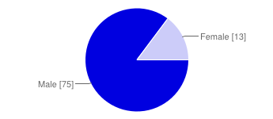
Interpretation :
Most of the respondents were males.

Your Occupation?
Total No. of Respondents = 88

Description | No. of respondents | % of respondents
Student | 11 | 13%
Service | 27 | 41%
Self Employed | 39 | 44%
Housewife | 11 | 13%

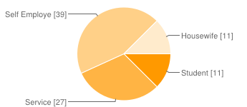

Interpretation:
The majority of the respondents constituted mostly
of business men or people employed with some kind of organization

Type of phone you use for communication?

Description | No. of respondents | % of respondents
Mobile phone | 88 | 100%
Landline | 0 | 0%
None | 0 | 0%

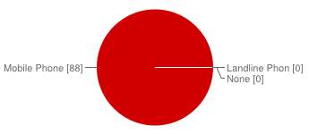
Interpretation :
All the respondents used mobile phones for their
communication

Which type of mobile do you use for communication?

Description | No. of respondents | % of respondents
Smartphone | 54 | 61%
Basic phone | 34 | 39%
None in case you don't use a mobile | 0 | 0%

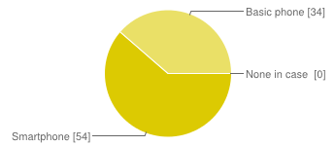

Interpretation:
The survey was well balanced with 61% of them as
smartphone users while 39% were basic phone users

Which service provider are you presently registered to?
Description | No. of respondents | % of respondents
Airtel | 31 | 35%
Aircel | 4 | 5%
Tata Indicom | 4 | 5%
Reliance | 24 | 27%
Uninor | 2 | 2%
Vodafone | 5 | 6%
Idea | 5 | 6%
BSNL | 13 | 15%

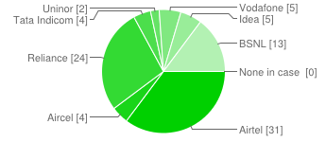

Interpretation :
Based on the result of the above survey, we can easily
say that Airtel and Reliance dominate the market,
though Airtel has a slight edge on Reliance, which is
largely contributed by its better service, network and data
speed(as reported by the respondents in the survey)

Why do you use the present service provider's services?

Description | No. of respondents | % of respondents
They have better network | 55 | 23%
They provide better service | 46 | 19%
They have better data speed (2G/3G/both) | 15 | 6%
The retail stores are easy to locate | 26 | 11%
Easy to get their services | 46 | 19%
You are Brand loyal | 18 | 7%
Offers the best price for its services | 35 | 14%
All of the above | 1 | 0%

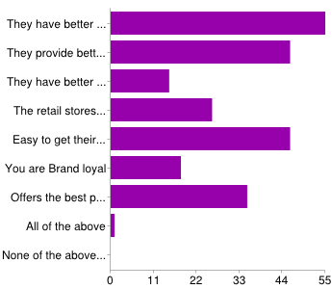

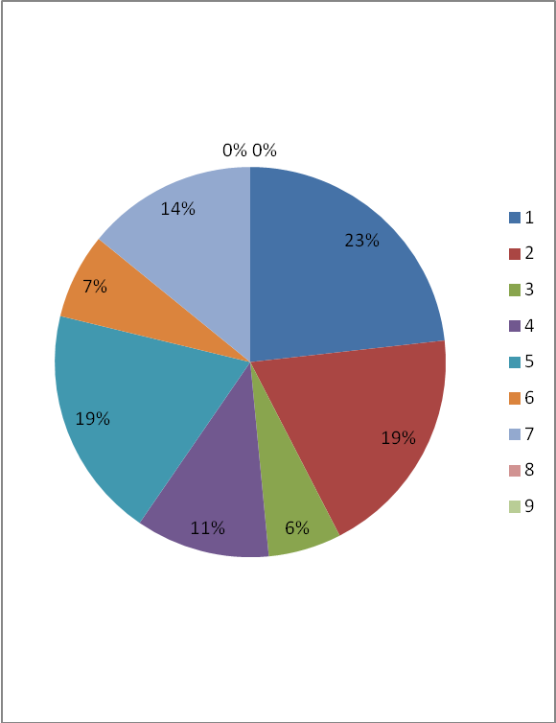

Interpretation :

As is evident from the response , the most important criteria for the respondents is better plan in terms of price offering and most importantly, better service in terms of network, customer service, data speed and good customer service
along with the ease with which the retailers, recharges etc are available.

What are your main usage on your phone?

Description | No. of respondents | % of respondents
STD calls | 38 | 22%
Local calls | 72 | 43%
Internet usage | 28 | 17%
Roaming | 18 | 11%
All of the above | 13 | 8%
None if you don't use a mobile | 0 | 0%

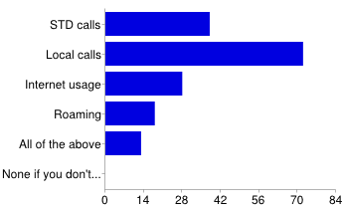

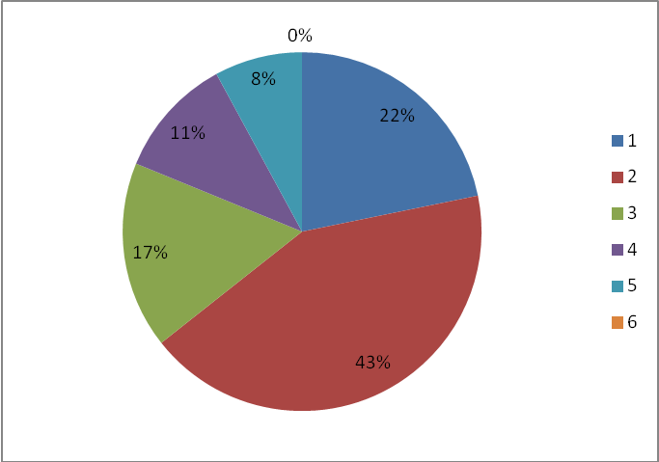

Interpretation :
Among the plans introduced, most of the
customers exclusively make local calls, thus, it
requires the most precise specification, followed
by internet usage (primarily 2G) and roaming
usages

Are you aware of competitors' plans?

Description | No. of respondents | % of respondents
Yes | 34 | 39%
No | 53 | 60%
N/A for non local usage priorities | 1 | 1%

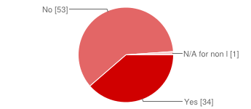
Interpretation :
Most of the users are unaware of the competitors’ plan so it is important to position Reliance’s products in their minds well

If Yes, which among the following?
Total No. of Respondents = 88

Description | No. of respondents | % of respondents
Airtel | 15 | 14%
Aircel | 9 | 8%
Reliance | 7 | 7%
Tata Indicom | 1 | 1%
Uninor | 0 | 0%
Vodafone | 8 | 7%
Idea | 1 | 1%
BSNL | 0 | 0%
Don't know about competitors' plans | 52 | 49%
All of the above | 12 | 11%
N/A for non local usage priorities | 2 | 2%

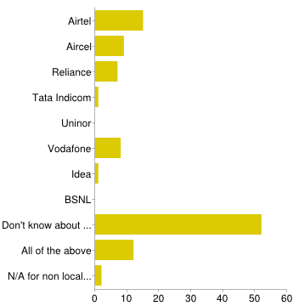
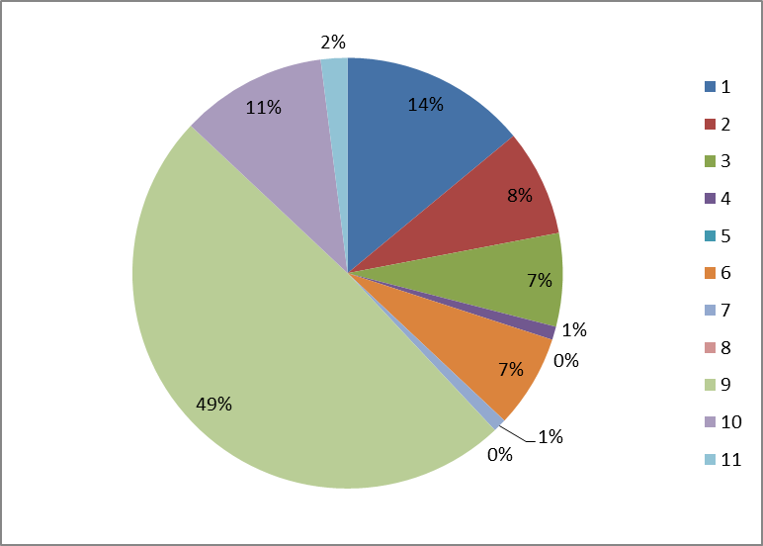
Interpretation
Most of the folks who were interviewed, don't know about competitors. So, it is important to advertise the product in such a manner that it shows how superior it is to the competitors. This can be done through pamplets, hoardings, face to face marketing etc.

Do you know about Reliance's Rs 54 tariff plan for local calls?

Description | No. of respondents | % of respondents
Yes | 18 | 21%
No | 67 | 77%
N/A for non local usage priorities | 2 | 2%

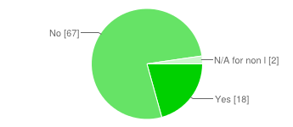

Interpretation :
Most of the customers that were interviewed did not know about the plan.It is important to make them aware first through strategic promotion and advertising techniques, smses and calls to existing customers while through hoardings, pampletsetc for creating general awareness

Would you like to switch to the above plan?

Description | No. of respondents | % of respondents
Yes | 39 | 44%
No | 47 | 53%
N/A for non local usage priorities | 2 | 2%

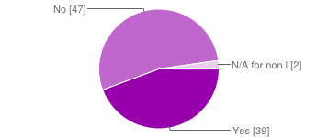

Interpretation:
More people will switch if the service and network gets better

If yes, Why?

Description | No. of respondents | % of respondents
Better Price | 40 | 34%
Better Service | 10 | 9%
Better Network | 5 | 4%
Better plan than the competitors | 16 | 14%
All of the above | 0 | 0%
N/A for non local usage priorities or option (b) chosen in the previous question | 46 | 39%

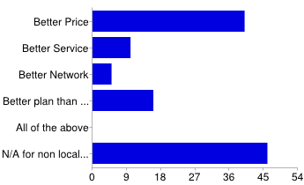

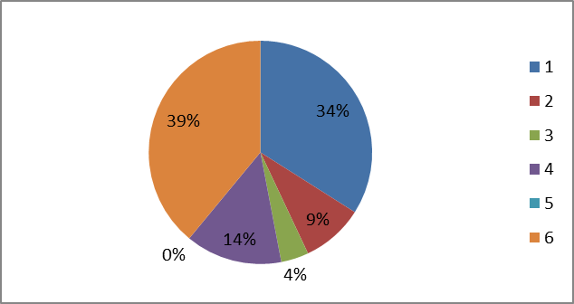

Interpretation :
As is eveident that Reliance's plan is very good
and the offered price is very good too. No changes are required there

If No, Why?

Description | No. of respondents | % of respondents
Reluctant to change your number | 28 | 26%
You are Brand loyal | 14 | 13%
Fine with the current plan | 23 | 21%
All of the above | 1 | 1%
N/A for non local usage priorities or for option (a) chosen in the last to the last question above | 42 | 39%

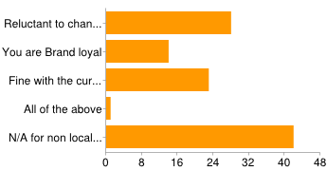

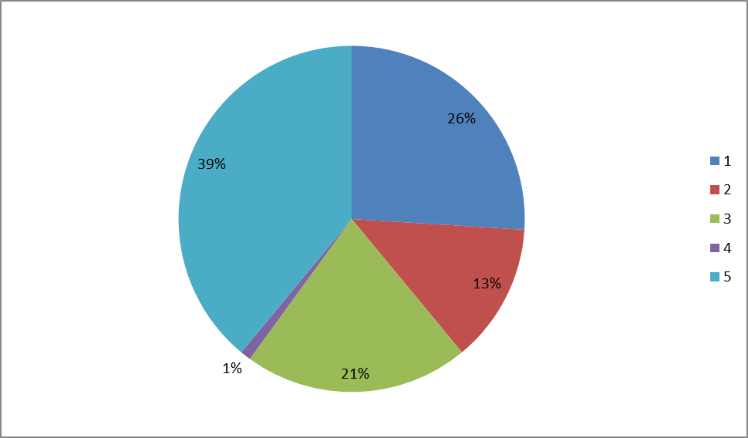

Interpretation :
Most people don't want to switch as they are reluctant to change numbers. Brand loyal peopleare those of BSNL mostly. So, if strong positioning is done through a positive combination of better price, plan, service, network and advertisement
, this plan is sure to pull of these customers too.

Are you aware of Reliance's (RS 115 - TT 120) and RS 46 Roaming tariff plans?

Description | No. of respondents | % of respondents
Yes | 12 | 14%
No | 27 | 31%
N/A for non roaming usage | 49 | 56%
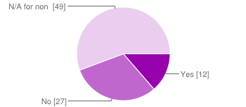

Interpretation
Most of the customers that were interviewed did not know about the plan.It is important to make them aware first through strategic promotion and advertising techniques, smses and calls to existing customers while through hoardings, pamplets etc for creating general awareness

Would you like to switch to either of the above Roaming tariff plans of Reliance?

Description | No. of respondents | % of respondents
Yes | 16 | 18%
No | 22 | 25%
N/A for non roaming usage | 50 | 57%

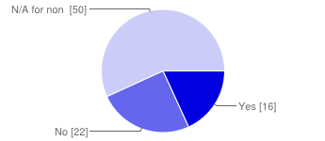
Interpretation
Most of the customers that were interviewed did not know about the plan
.It is important to make them aware first through strategic promotion and advertising techniques, smses and calls to existing customers while through hoardings,
pamplets etc for creating general awareness

If Yes, why?
Description | No. of respondents | % of respondents
Better Price offering | 15 | 15%
Better Plan | 12 | 12%
Better Network | 2 | 2%
Better Service | 0 | 0%
All of the above | 0 | 0%
N/A for non roaming usage | 70 | 71%

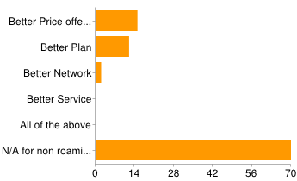
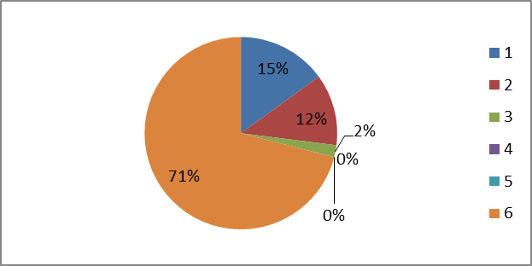
Interpretation
Reliance has best price and plan offering

If No, Why?
Description | No. of respondents | % of respondents
Reluctant to change your number | 11 | 12%
You are Brand loyal | 08 | 08%
Fine with the current plan | 09 | 09%
All of the above | 1 | 1%
N/A for non roaming usage priorities or option (a) chosen in the last to last question above | 66 | 69%

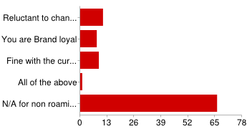

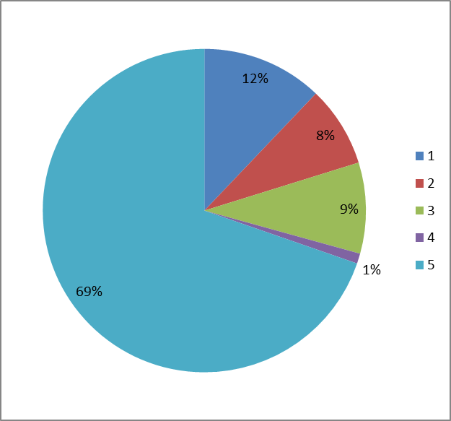

Interpretation:

Most people don't want to switch as they are reluctant to change numbers. Brand loyal people are those of BSNL mostly. So, if strong positioning is done through a positive combination of better price, plan, service, network and advertisement, this plan is sure to pull off these customers too.

What is your basic plan for mobile internet?
Description | No. of respondents | % of respondents
2G | 21 | 24%
3G | 21 | 24%
N/A for non internet usage priorities or for basic phone type | 46 | 52%

Are you aware of Reliance's (RS 177 - 1GB - 3G) plan?
Description | No. of respondents | % of respondents
Yes | 6 | 7%
No | 35 | 40%
N/A for non internet usage priorities or for basic phone type | 47 | 53%

Interpretation:
Most of the customers that were interviewed did not know about the plan
.It is important to make them aware first through strategic promotion and advertising
techniques, smses and calls to existing customers while through hoardings,
pamplets etc for creating general awareness

Are you aware of Reliance's (RS 125 - 1GB - 2G) plan?

Description | No. of respondents | % of respondents
Yes | 10 | 11%
No | 31 | 35%
N/A for non internet usage priorities | 47 | 53%
Interpretation:
Most of the customers that were interviewed did not know about the plan
.It is important to make them aware first through strategic promotion and advertising
techniques, smses and calls to existing customers while through hoardings,
pamplets etc for creating general awareness

Would you like to switch to either of the offered plans of Reliance?
Description | No. of respondents | % of respondents
Yes | 19 | 22%
No | 23 | 26%
N/A for non internet usage priorities or for basic phone type | 46 | 52%

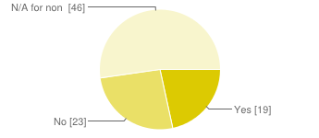
Interpretation:
People are willing to switch
because of better price and plan. By creating awareness and advertising, more people would switch

If Yes, Why?

Description | No. of respondents | % of respondents
Better Price offering | 19 | 18%
Better Service | 6 | 6%
Better Speed | 4 | 4%
Better 3G plan than competitors (In case of 3G) | 5 | 5%
Better 2G plans than competitors (In case of 2G) | 5 | 5%
N/A for non internet usage priorities or for basic phone type | 47 | 47%
N/A for option b chosen in the question above | 19 | 19%

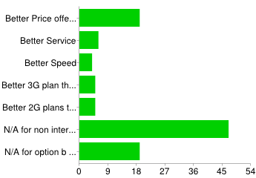

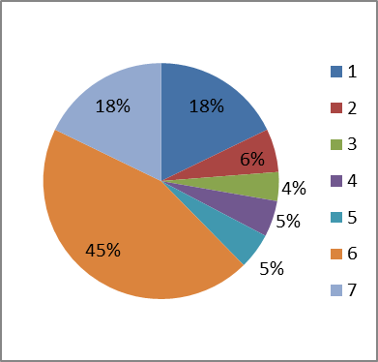

Interpretation
People are willing to switch because of better price and plan

If No, Why?

Description | No. of respondents | % of respondents
Current Service Provider has a very good 3G speed | 8 | 8%
Current Service Provider has a very good 2G speed | 7 | 7%
You are Brand loyal | 4 | 4%
You are reluctant to change your number | 13 | 12%
Fine with the current plan | 9 | 8%
N/A for non internet usage priorities or for basic phone type | 46 | 43%
N/A for option (a) chosen in the last to the last question above | 19 | 18%

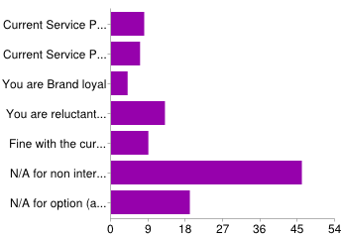

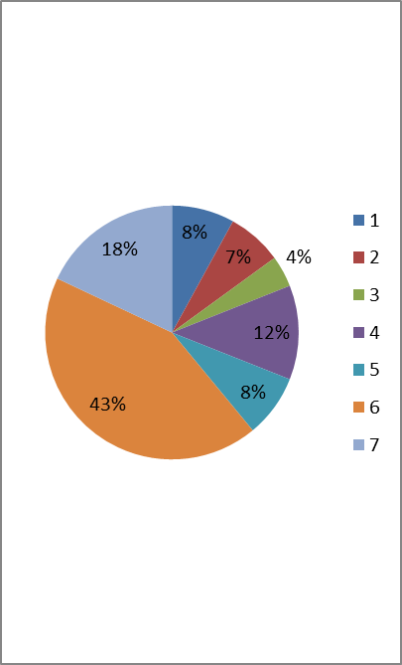

Interpretation
Most people don't want to switch as they are reluctant to change numbers. Brand loyal people are those of BSNL mostly. So, if strong positioning
is done through a positive combination of better price,plan, service, network and advertisement , this plan is sure to pull off these customers too. Further, Reliance needs to speed up its 2G more as Airtel is much better in this field

Retailers :

Which among the following do you sell?

Description | No. of respondents | % of respondents
Scratch card | 0 | 0%
Easy Recharge | 33 | 77%
Both | 10 | 23%

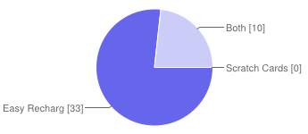
Interpretation
Most of the retailers sell easy recharge now. Scratch card is somewhat becoming obsolete now.

Which among the following do you sell for?
Description | No. of respondents | % of respondents
Airtel | 5 | 8%
Aircel | 2 | 3%
BSNL | 1 | 2%
Idea | 4 | 6%
Reliance | 5 | 8%
Tata Indicom | 4 | 6%
Uninor | 2 | 3%

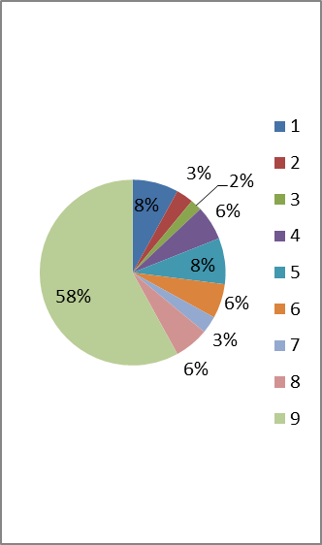
Interpretation
Most retailers sell for almost all the service providers. The market has become monopolistically competitive where one which differentiates itself even slightly, can sell more (if done properly) keeping the competitors' plans in mind

How many recharges do you do per day?

Description | No. of respondents | % of respondents
0-20 | 1 | 2%
20-50 | 6 | 14%
50-100 | 19 | 44%
>100 | 17 | 40%

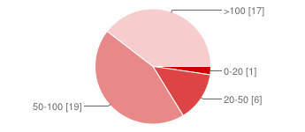

Do you know about Rs 54 tariff of Reliance for local calls?

Description | No. of respondents | % of respondents
Yes | 19 | 44%
No | 24 | 56%

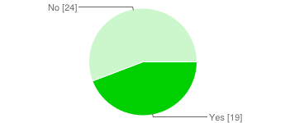
Interpretation
Even the retailers shall be made to know well. This can be done by making the distributors more active and there performances shall be measured not only on their sales quantity but also on how effectively they train retailers and spread awareness among them (qualitative)

Any modification that you suggest for the above plan?

Description | No. of respondents | % of respondents
Include STD with Local | 25 | 19%
Increase validity | 24 | 18%
Merge GSM and CDMA (like docomo) | 14 | 11%
Reduce the rate a bit or increase validity | 21 | 16%
Network should get better | 20 | 15%
Service should get better | 21 | 16%
All of the above | 4 | 3%
None of the above | 1 | 1%

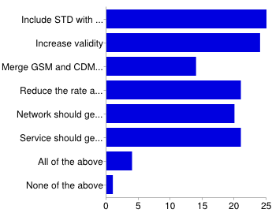

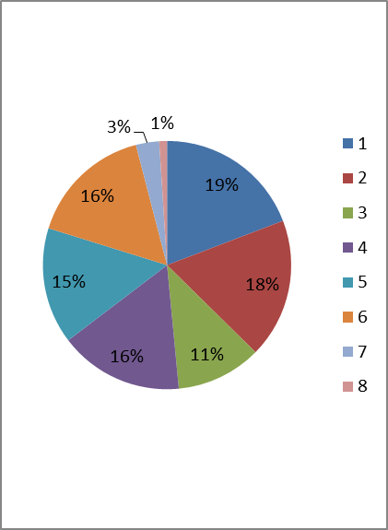

Interpretation
Most of the retailers want Reliance to include local along with STD plan.
They may increase the price to say rs 70, increase validity to 45 days and include STD with local

Do you know about the new 3G data plan of Reliance?

Description | No. of respondents | % of respondents
Yes | 14 | 33%
No | 29 | 67%

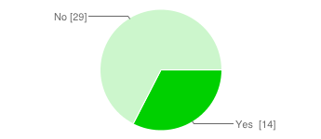

Interpretation
Even the retailers shall be made to know well. This can be done by making the distributors more active and there performances shall be measured not only on their sales quantity but also on how effectively they train retailers and spread awareness among them (qualitative)

Do you know about the new 2G data plan of Reliance?
Description | No. of respondents | % of respondents
Yes | 14 | 33%
No | 29 | 67%

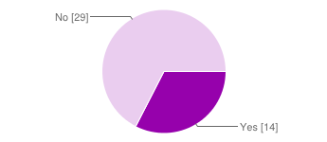

Interpretation
Even the retailers shall be made to know well. This can be done by making the distributors more active and there performances shall be measured not only on their sales quantity but also on how effectively they train retailers and spread awareness among them (qualitative)

Any modification that you suggest for the above plan s of Reliance?

Description | No. of respondents | % of respondents
Speed can improve for 3G | 19 | 11%
Speed can improve for 2G | 30 | 17%
Validity can be increased for 2G | 32 | 18%
Price can be reduced for 3G | 5 | 3%
Validity can be increased for 3G | 5 | 3%
Price can be reduced for 2G | 25 | 14%
Service can improve | 24 | 14%
Network can improve | 26 | 15%
All of the above | 6 | 3%
None of the above | 1 | 1%

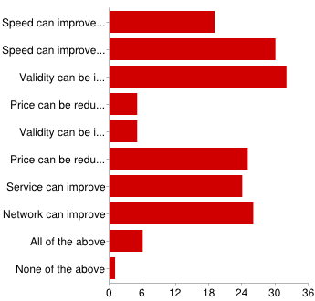

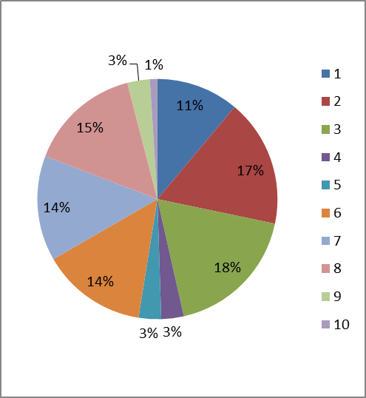

Interpretation
Most retailers want the validity for 2G to be increased to 30 days. Further,
Airtel has better 2G and 3G speeds. Reliance needs to improve on speed and customer service too.

Distributors :
In addition to the customers and retailers, responses of a few distributors were noted to check for the concerns if they might have.

Are you aware of the following plans of Reliance (Tick check boxes if you know)?
Description | No. of respondents | % of respondents
Local | 11 | 28%
Roaming | 7 | 18%
3G plan | 11 | 28%
2G plan | 11 | 28%

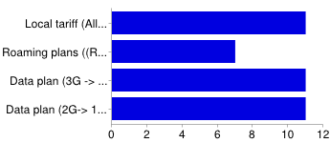

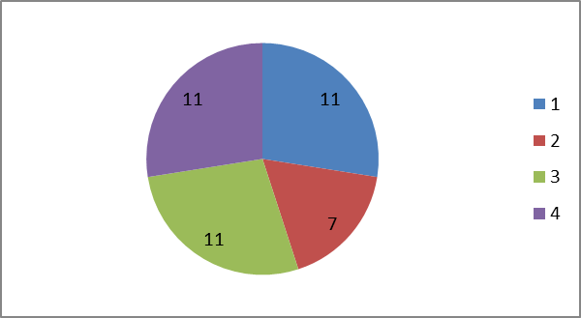

Interpretation
Most distributors are aware of all the plans , however a few are not knowing about the roaming plans so it is important to create awareness among them about the roaming plans, first

Which plans from above have you sold?
Description | No. of respondents | % of respondents
Local | 11 | 28%
Roaming | 7 | 18%
3G plan | 11 | 28%
2G plan | 11 | 28%

Interpretation
Most distributors sell all the plans, however a few do not sell the roaming plans and these are generally those who are not aware of the plan

A few concerns that were raised by the distributors and Reliance shall take care of these with immediate effect :

- Improve seniors' involvement
- DSR's shall be paid well
- Call rate shall be decreased as compared to other networks
- The service shall improve
- Internet plans are not satisfactory when compared to competitors. 2G plan's validity shall be increased
- Tariff shall be made better to match very low cost competitors
- Team visit shall happen more frequently Money due, required immediate remittance
- Lot of pressure on distributors due to the loans not paid on time from the market
- Work culture shall improve. Salesman satisfaction shall be more. Seniors shall share more responsibilities

SWOT Analysis

Strength :-
- Low Entry Cost
- Commission Structure
- Fast Activation Process
- Network
- Connectivity
- Data GPRS & 3G
- Established market
- Wide customer base

Weakness :-
- Branding Image
- Distribution problem
- Limited product portfolio - Only Mobile
- Lack of Competitive Strength
- Limited Budged
- Poor service image
- Lax management

Threats :-
- Political destabilization
- New Entrants
- IT Development
- Market Demand
- Seasonality, Weather Effects

Opportunity :-
- Preference of GSM over CDMA
- New Specialist Application.
- Rural Telephony
- New Market, Vertical, Horizontal
- Competitor's Vulnerabilities

Chapter - 5

- Findings
- Recommendations

Findings

Based on the survey results, I evaluated the data for Customers and Retailers individually to check for the effects of various parameters like Price, Plan, offers , Network, Customer service and an association of these to determine as to which of these factors contribute to the most in increasing the sales via the number of recharges made per day.

I performed chi square analysis to check for the association among the variables in addition to the various statistical analysis carried out in the previous section.

THE CHI SQUARE ANALYSIS and FINAL FINDINGS :

CUSTOMERS :

- Analysis for the launch of Local Plan pack :

Chi Square analysis to see what are the most important traits that the customers measure (General Case – Applicable) before buying a particular recharge plan or before switching between service providers ( includes all the service providers)?

Increase in sales and increase in the number of loyal customers |  | Low Price |  | Price not a factor |  | Total number of respondents
 | Service not a factor | Good service |  | Service not a factor | Good service
Yes | 13 | 22 |  | 4 | 48 | 87
No | 22 | 13 |  | 48 | 4 | 87
Total number of respondents | 35 | 35 |  | 52 | 52 | 174

Hypothesis :
H0 : There is no association between low price and good service
H1 : There is an association between low price and good service
Chi Square value : 116 . At 0.05 level of significance and degrees of freedom of
3, the chi square table gives a value of 11.85. Thus, H0 is rejected.
The strength of association is .755 and is quite significant.

Thus, it is evident that low price and good service are the reasons in combination that makes a customer use the services of a particular service provider.

Further analysis :
Customers switching to Reliance only for low price or better plan (in terms of value for money) factor only : 28
Customers switching to Reliance only saying that it provides better service only : 2
Customers reluctant to switch to Reliance citing poor service only : 2
Customers saying both, good service and low price only (Mostly existing Reliance customers only) : 11

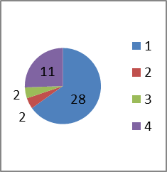

Thus, People are more satisfied with Reliance when it comes to price and good plans. However, when it comes to service,it lags behind its closest competitor, Airtel. 28 people are willing to take the plan because of its low price and
better offer. However, people satisfied with both , Service and Price makes 39 customers switching to the above plan. Further, if it provides good service, it can also attract the two customers who are not willing to switch due to poor service, making the total count as 41. This will help Reliance beat Airtel and increase the daily number of recharges, thus increasing sales. Chi square analysis above too confirms the fact that low price and good service go hand in hand for bolstering the sales for Reliance.

- Analysis for the launch of Roaming Plan pack :

Chi Square analysis to see what are the most important traits that the customers measure (General Case – Applicable) before buying a particular recharge plan or before switching between service providers ( includes all the service providers)?

Increase in sales and increase in the number of loyal customers |  | Low Price |  | Price not a factor |  | Total number of respondents
 | Service not a factor | Good service |  | Service not a factor | Good service
Yes | 13 | 22 |  | 4 | 48 | 87
No | 22 | 13 |  | 48 | 4 | 87
Total number of respondents | 35 | 35 |  | 52 | 52 | 174

Hypothesis :
H0 : There is no association between low price and good service
H1 : There is an association between low price and good service
Chi Square value : 116 . At 0.05 level of significance and degrees of freedom of
3, the chi square table gives a value of 11.85. Thus, H0 is rejected.

The strength of association is .755 and is quite significant.

Thus, it is evident that low price and good service are the reasons in combination that makes a customer use the services of a particular service provider.
Customers switching to Reliance only for low price or better plan (in terms of value for money) factor only : 14
Customers switching to Reliance only saying that it provides better service only : 2
Customers reluctant to switch to Reliance citing poor service only : 2
Customers saying both, good service and low price only (Mostly existing Reliance customers only) : 0

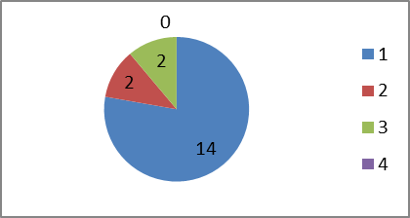
Thus,people are more satisfied with Reliance when it comes to price and good plans. However, when it comes to service,it lags behind its closest competitor, Airtel. 14 people are willing to take the plan because of its low price and
better offer. Further, if it provides good service, it can also attract the two
customers who are not willing to switch due to poor service, making the total
count as 16. This will help Reliance increase the daily number of recharges, thus increasing sales. Chi square analysis above too confirms the fact that low price and good service go hand in hand for bolstering the sales for Reliance. However, when it comes to the plan, this received the best response as very good plans from the customers.

- Analysis for the launch of Data Plan packs :

Chi Square analysis to see what are the most important traits that the customers measure (General Case – Applicable) before buying a particular recharge plan or before switching between service providers ( includes all the service providers)?

Increase in sales and increase in the number of loyal customers |  | Low Price |  | Price not a factor |  | Total number of respondents
 | Service not a factor | Good service |  | Service not a factor | Good service
Yes | 13 | 22 |  | 4 | 48 | 87
No | 22 | 13 |  | 48 | 4 | 87
Total number of respondents | 35 | 35 |  | 52 | 52 | 174

Hypothesis :
H0 : There is no association between low price and good service
H1 : There is an association between low price and good service
Chi Square value : 116 . At 0.05 level of significance and degrees of freedom of
3, the chi square table gives a value of 11.85. Thus, H0 is rejected.

The strength of association is .755 and is quite significant.

Thus ,it is evident that low price and good
service are the reasons in combination that makes a customer use the services
of a particular service provider.

Further Analysis :
Customers switching to Reliance only for low price or better plan (in terms of value for money) factor only : 28
Customers switching to Reliance only saying that it provides better service only : 2
Customers reluctant to switch to Reliance citing poor service only : 2
Customers saying both, good service and low price only (Mostly existing Reliance customers only) : 11

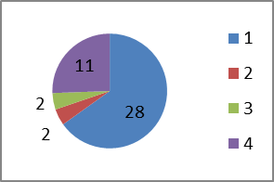

Thus, People are more satisfied with Reliance when it comes to price and good plans.
However, when it comes to service,it lags behind its closest competitor, Airtel. 28 people are willing to take the plan because of its low price and better offer. However,people satisfied with both , Service and Price makes 39 customers switching to the above plan. Further, if it provides good service, it can also attract the two customers who are not willing to switch due to poor service, making the total count as 41. This will help Reliance beat Airtel and increase the daily number of recharges, thus increasing sales. Chi square analysis above too confirms the fact that low price and good service go hand in hand for bolstering the sales for Reliance.

RETAILERS :

- Analysis for the launch of Local Plan pack :

Chi Square analysis to check the factors that would affect the sales in terms of the number of recharges done per day with respect to the factors like better price, plan and service offerings and association between a few of the such important factors

Sales |  | Better plan (Either include STD with local,  Increase validity, Merge GSM and CDMA , reduce the rate and increase validity or incorporate all) | Total number of respondents
 | Service not a factor | Good service
Will Increase | 13 | 29 | 42
May remain constant or decrease | 29 | 13 | 42
Total number of respondents | 42 | 42 | 84

Hypothesis :
H0 : There is no association between better plan and good service
H1 : There is an association between better plan and good service
Chi Square value : 45.26 . At 0.05 level of significance and degrees of freedom of
1, the chi square table gives a value of 7.85. Thus, H0 is rejected.

The strength of association is .72 and is quite significant.

Thus , the strength of association .72 is significant so the betterment of plan shall be done with an improvement in service and network too to reap maximum sales. Example of Airtel which is costly and has limited plans than Reliance but is comparable to Reliance in the market because of its better services and network

Chi square analysis to check the association between including STD with local
and increasing validity(with or without decreasing price),holding the other factors like services, network, merging of CDMA and GSM etc constant

Sales |  | Include STD with local |  | Don't Include STD with local |  | Total number of respondents
 | Increase validity | Don't increase validity |  | Increase validity | Don't increase validity
Will increase | 24 | 4 |  | 13 | 1 | 42
May remain constant or will decrease | 4 | 24 |  | 1 | 13 | 42
Total number of respondents | 28 | 28 |  | 14 | 14 | 84

Hypothesis :
H0 : There is no association between including STD and increasing validity
H1 : There is association between including STD and increasing validity
Chi Square value : 66.57 . At 0.05 level of significance and degrees of freedom of
3, the chi square table gives a value of 11.85. Thus, H0 is rejected.

The strength of association is .78 and is quite significant.

Further Analysis :
No of retailers wanting only STD inclusion : 24
No of retailers wanting only validity increase : 13
No of Retailers wanting both : 9



It is evident that most retailers suggest that both, including
STD with local and increasing validity to say 45 days would
attract more customers. However, most of them want the STD pack
to be included. Thus, Reliance should either incorporate
both or at least include STD with local

- Analysis for the launch of Data Plan pack :

Chi square analysis to check for the parameters like better speed for 2G and increasing the validity for the 2G plan on sales and the association between the formers on the latter
Sales |  | Speed shall  get better for 2G | Total number of respondents
 | Increase validity (min 30 days) | Don't increase validity  (let it be 21 days)
Will Increase | 35 | 1 | 36
May remain constant or decrease | 1 | 35 | 36
Total number of respondents | 36 | 36 | 72

H0 : There is no association between increasing speed and validity
H1 : There is an association between increasing speed and validity
Chi Square value : 34.05 . At 0.05 level of significance and degrees of freedom of
1, the chi square table gives a value of 7.85. Thus, H0 is rejected.

The strength of association is .664 and is quite significant.
The strength of association .664 is significant so
Reliance shall improve its 2G speed to capture market share and get better than Airtel. Further it shall definitely improve on the validity period and make it atleast 30 days for the 2G data plan. If both done simultaneously, will definitely improve sales.

Further Analysis :
No of retailers wanting only 2G speed increase : 1
No of retailers wanting only validity increase: 3
No of retailers wanting both: 35

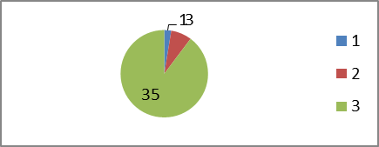

Thus, as evident from the data above, most retailers want that
both, 2G speed as well as validity shall increase to get maximum
sales. Doing either will not have the same affect as doing the
former. Thus, it is suggestible to increase the validity atleast to
30 days and improve the 2G speed along with service and
network. Also, 22 retailers said that even the 3G speed shall
also increase. As proved earlier, Airtel has a better speed, Reliance
urgently needs to get its speed better for both, 2G and 3G
Recommendations
For the Local calls pack (Based on the reviews and findings based on those reviews for, customers, retailers and distributors) :

- Include STD with local, increase the price to Rs 60 and increase the validity to 45 days
- The plan is good, need to have good service and network
- Would be best if it offers as good a network as Airtel
- Shall not deduct money on the name of VAS
- They should be more consistent with their service and customer care

For the Roaming calls pack (Based on the reviews and findings based on those reviews for, customers, retailers and distributors) :
- Rs 46 can be reduced to 40 or something to match competitors . Similarly reduce 115 to 80, give TT of 90 or for 115, increase validity up to 2 months at least
- 120 talk time is too much for someone who talks less. Further, people don't exclusively get recharged for roaming, paying such a large amount (there mindset, reluctance and attitude to listen in details and usually such promotions come in low amounts). Best is that either reduce the amount to 75 rs , TT of 80 or for current amount, increase the validity to 60 days

For the Data plans pack (Based on the reviews and findings based on those reviews for, customers, retailers and distributors) :
- Price can be reduced for 2G (not that much value for money). Other service providers’ rates are lesser
- Customer service and network speed shall improve
- Server downtime and low connectivity shall be reduced to overcome Airtel's market which has better service, network, data speed
- The network connection of GSM gets disconnected abruptly. Shall be resolved.
- 3G shows 500 MB for 1 GB recharge sometimes. This hall be resolved. However people complain that the Customer care doesen't respond well. This shall be taken care of well.

Apart from this, Reliance has a poor service when it comes to customer service and its network, data speed too is not that good. It shall definitely improve on these as other competitors are picking up. Further, the telecom market has become more open market kind and Reliance shall improve on its service to not lose out on the market which it has built over years to other , relatively new entrants. Seniors shall take more responsibility and shall show more involvement. On the front of distributors, they say that the salaries of DSRs shall as per their working. It shall be given based on both, qualitative as well as quantitative work done.Seniors shall take more responsibilities, more senior visits shall occur and the work culture shall improve.

Chapter - 6

- Conclusion
- Limitations
- Bibliography

Conclusion
According to the survey conducted by me for 88 customers, 43 retailers and a few distributors that use GSM mobile phones of Reliance in areas of Bihar and Jharkhand,. I found that most of the customers, retailers and distributors are mostly dissatisfied by the services that Reliance provides. Given its market spread and creeping up of Airtel, it is important that Reliance shall pick up on its shortcomings. Most of the respondents agree that the plans and price offerings that Reliance offers, are very good. However, in terms of services, determined by the factors like good and efficient network, good 2G and 3G speed, transparent billing services, more responsible senior employees and DSRs and a grievance listening and solving customer care staff. There should be a special place on the prime location to hear complains of the existing customers and recruit responsible employees to solve their problems. Also, I have done a detailed analysis of what is the requirement that leads to the efficient marketing of the new products that are being launched. If Reliance wins over the hearts of its users through great service quality and agility, it is hundred percent sure that the plans that it is offering are more or less close to wonderful !
Other concerns, laudatory things and recommendations have already been included earlier.

Limitations

(i) Limitation of time :-

The time allowed for the study was not sufficient , so it was not possible to adopt full methodology within the stipulated time.

(ii) Limitation of finance :-

It had not been possible to make in depth study in above respect due to the limitation of finance.

(iii) Limitation of area :-

It was not possible to survey the Bihar and Jharkhand telecomm market due to the lack of time and finance.

(iv) Some other Limitations :-

(a) More stress was given on primary data as it was difficult to collect secondary data from organization.
(b) The result of Survey are based upon crucial assumptions like -
- The respondents know the right answer to the question put to them.
- They are willing to give the right answer.
(c) All the conclusion and suggestion will be made in the feedback obtained from survey on the basis of responses given by respondents.

In spite of all those limitations efforts were made on my part to come out with whatever possible information was gathered and give view/points on it in the form of suggestion at the concluding part of this project.

Bibliography

Marketing Management :- Philip Kotler
Research Methodology :- C.R.Kothari
Sales Management :- Still candiff and sand Govoni
Marketing Research :- NK Malhotra
Magazines :- Business Today, Business World
Newspaper :- The Economic Times
The Times of India

Website : www.google.co.in
www.scribed.org
www.rcom.co.in

